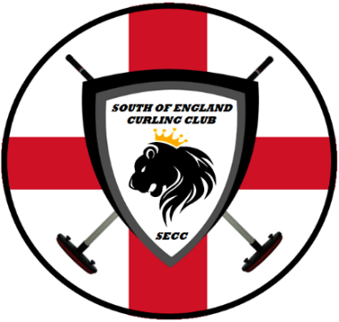
SECC: SOUTH OF ENGLAND CURLING CLUB
2016-2017: Membership Form
www.secc.rocks

Adult  Competitive  £30  If you are a competitive curler and plan to participate in ECA events (National Playdowns etc) | Junior  Competitive  £25  If you are a competitive curler and plan to participate in ECA events (National Playdowns etc) | Club  Member  £20  If you are a social curler and do not plan to participate in ECA events (National Playdowns etc)
- Eligible to participate in all SECC activities  (on-ice and off-ice)  - Can be elected to the SECC committee  - Can attend General Meetings and vote.  - Membership includes ECA subscription fee. | - A member under the age of 21 on the 30th June preceding the start of a season.  - Eligible to participate in all SECC activities  (on-ice and off-ice)  - Can attend General Meetings and vote.  - Membership includes ECA subscription fee. | - Eligible to participate in all SECC activities  (on-ice and off-ice)  - Can be elected to the SECC committee  - Can attend General Meetings and vote.  - Membership DOES NOT include ECA subscription fee.

First Name:_______________ | Last Name:_______________
Date Of Birth:_____________ | Email Address:_____________
Home Phone #:____________ | Mobile Phone #:____________
Years Curled:_____________ | Membership Type:__________

Payment details - Account Number: 4149 6239 – Sort Code: 40-18-48
Please return your form to secretary.secc.rocks@gmail.com and make payment to confirm your membership.
THANK YOU

